Name : RAGYARI SAHASRA REDDY Class : CSE(AI)-B RollNo : 160724754069
Date:03/02/2025
Week-1
1)Create an account in github and link the repository with the google colab

PART 1: Create a GitHub Account
- Go to 👉 https://github.com
- Click Sign Up
- Enter:
  - Email
  - Password
  - Username (choose something cool 👀)
- Verify email
- Done 🎉
Now you officially exist on GitHub.

PART 2: Create a Repository
- Click your profile icon (top right)
- Click Your repositories
- Click New
- Fill:
  - Repository name (example: Data-Science-Programs)
  - Keep it Public (easier for now)
  - ✔ Add README (optional)
- Click Create repository
Boom 💥 repo created.

PART 3: Link GitHub with Google Colab
Now we connect it with Google Colab.
- Open https://colab.research.google.com
- Click File → Save a copy in GitHub
- It will ask to:
  - Authorize GitHub
- Choose:
  - Your repository
  - File name
- Click OK
Done ✅
Your notebook is now directly saved in GitHub.

2)Write the code to implement the following data structures—lists,tuples,sets,dictionaries
LISTS:-
1-accesing elements
# Accessing elements
lst = [10, 20, 30, 40]
print("First element:", lst[0])
print("Last element:", lst[-1])

output:
First element: 10
Last element: 40

2-Adding elements
#Adding elements
lst = [10, 20, 30, 40]
lst.append(50)
print("After append:", lst)
lst.insert(2, 25)
print("After insert:", lst)
lst.extend([60, 70])
print("After extend:", lst)

output-
After append: [10, 20, 30, 40, 50]
After insert: [10, 20, 25, 30, 40, 50]
After extend: [10, 20, 25, 30, 40, 50, 60, 70]

3-Updating elements
# Updating element
lst = [10, 20, 30, 40]
lst[0] = 100
print("After updating:", lst)

output-
After updating: [100, 20, 30, 40]

4-Removing Elements
# Removing elements
lst = [10, 20, 30, 40]
lst.remove(30)
print("After remove:", lst)
lst.pop()
print("After pop:", lst)
lst.pop(1)
print("After pop at index 1:", lst)

output-
After remove: [10, 20, 40]
After pop: [10, 20]
After pop at index 1: [10]

5-searching elements
# Searching
lst = [10, 20, 30, 40]
print("Index of 30:", lst.index(30))
print("Count of 20:", lst.count(20))

output-
Index of 30: 2
Count of 20: 1

6-looping in lists
# Looping
lst = [10, 20, 30, 40]
print("Elements in list:")
for item in lst:
print(item)

output-
Elements in list:
10
20
30
40

7-clearing lists
# Clearing list
lst = [10, 20, 30, 40]
lst.clear()
print("After clear:", lst)

output-
After clear: []

TUPLES:-
1-creation of tuple
# Creating tuples
t = (10, 20, 30, 40, 20)
print("Original tuple:", t)

output-
Original tuple: (10, 20, 30, 40, 20)

2-accessing elements
# Accessing elements
t = (10, 20, 30, 40, 20)
print("First element:", t[0])
print("Last element:", t[-1])

output-
First element: 10
Last element: 20

3-slicing
# Slicing
t = (10, 20, 30, 40, 20)
print("Sliced tuple:", t[1:4])

output-
Sliced tuple: (20, 30, 40)

4-Length of tuple
# Length
t = (10, 20, 30, 40, 20)
print("Length of tuple:", len(t))

output-
Length of tuple: 5

5-counting elements
# Counting elements
t = (10, 20, 30, 40, 20)
print("Count of 20:", t.count(20))

output-
Count of 20: 2

6-finding index element in tuple
# Finding index
t = (10, 20, 30, 40, 20)
print("Index of 40:", t.index(40))

output-
Index of 40: 3

SETS:-
# SET OPERATIONS
s1 = {10, 20, 30, 40}
s2 = {30, 40, 50, 60}
print("Union using method:", s1.union(s2))
print("Intersection using method:", s1.intersection(s2))
print("Difference using method:", s1.difference(s2))
print("Symmetric difference using method:", s1.symmetric_difference(s2))

output-
Union using method: {40, 10, 50, 20, 60, 30}
Intersection using method: {40, 30}
Difference using method: {10, 20}
Symmetric difference using method: {10, 50, 20, 60}

DICTIONARIES:-
# Creating a dictionary
d = {
"name": "Amulya",
"age": 20,
"course": "BTech"
}
print("Original dictionary:", d)
# Accessing values
print("Name:", d["name"])
print("Age:", d.get("age"))
# Adding a new key-value pair
d["college"] = "XYZ University"
print("After adding:", d)
# Updating value
d["age"] = 21
print("After updating:", d)
# Removing elements
d.pop("course")
print("After pop:", d)
removed_item = d.popitem()
print("After popitem:", d)
print("Removed item:", removed_item)
# Keys, values, items
print("Keys:", d.keys())
print("Values:", d.values())
print("Items:", d.items())
#Length
print("Length of dictionary:", len(d))
# Looping through dictionary
print("Looping through keys:")
for key in d:
print(key, ":", d[key])
print("Looping through key-value pairs:")
for k, v in d.items():
print(k, "->", v)
# Updating using update()
d.update({"city": "Hyderabad", "age": 22})
print("After update():", d)
# Nested dictionary
student = {
"id": 1,
"info": {
"name": "Amit",
"marks": 90
}
}
print("Nested dictionary value:", student["info"]["marks"])
# Clearing dictionary
d.clear()
print("After clear:", d)

output-
Original dictionary: {'name': 'Amulya', 'age': 20, 'course': 'BTech'}
Name: Amulya
Age: 20
After adding: {'name': 'Amulya', 'age': 20, 'course': 'BTech', 'college': 'XYZ University'}
After updating: {'name': 'Amulya', 'age': 21, 'course': 'BTech', 'college': 'XYZ University'}
After pop: {'name': 'Amulya', 'age': 21, 'college': 'XYZ University'}
After popitem: {'name': 'Amulya', 'age': 21}
Removed item: ('college', 'XYZ University')
Keys: dict_keys(['name', 'age'])
Values: dict_values(['Amulya', 21])
Items: dict_items([('name', 'Amulya'), ('age', 21)])
Length of dictionary: 2
Looping through keys:
name : Amulya
age : 21
Looping through key-value pairs:
name -> Amulya
age -> 21
After update(): {'name': 'Amulya', 'age': 22, 'city': 'Hyderabad'}
Nested dictionary value: 90
After clear: {}

3)Write the code to download,save and transform data sets from the URL
import pandas as pd
# URL of dataset (example CSV)
url = "https://raw.githubusercontent.com/mwaskom/seaborn-data/master/iris.csv"
# Download data
df = pd.read_csv(url)
# Save dataset locally
df.to_csv("iris_dataset.csv", index=False)
print("Dataset downloaded and saved successfully!")
# ---- Transformations ----
# Display first 5 rows
print(df.head())
# Add a new column (example transformation)
df["sepal_area"] = df["sepal_length"] * df["sepal_width"]
# Save transformed data
df.to_csv("iris_transformed.csv", index=False)
print("Dataset transformed and saved!")

output-
Dataset downloaded and saved successfully!
sepal_length sepal_width petal_length petal_width species
0 5.1 3.5 1.4 0.2 setosa
1 4.9 3.0 1.4 0.2 setosa
2 4.7 3.2 1.3 0.2 setosa
3 4.6 3.1 1.5 0.2 setosa
4 5.0 3.6 1.4 0.2 setosa
Dataset transformed and saved!

4)Write the code to create,save and read the file from the local drive to perform the text operations (count number of lines, words and characters)
# Create and write to a file
file_name = "sample_text.txt"
with open(file_name, "w") as file:
file.write("Hello World\n")
file.write("This is a Python file handling example\n")
file.write("Counting lines words and characters")
print("File created and data written!")
# Read file and perform operations
with open(file_name, "r") as file:
text = file.read()
# Count lines
lines = text.split("\n")
line_count = len(lines)
# Count words
word_count = len(text.split())
# Count characters
char_count = len(text)
print("Number of lines:", line_count)
print("Number of words:", word_count)
print("Number of characters:", char_count)

output-
File created and data written!
Number of lines: 3
Number of words: 14
Number of characters: 86

Date:10/02/2025
Week-2
5)Write the code to implement the following searching algorithms– linear search , binary search
#LINEAR SEARCH
n=int(input("Enter number of elements:"))
arr=[]
for i in range(n):
arr.append(int(input(f"Enter element{i+1}:")))
key=int(input("Enter element to be searched:"))
found=False
for i in range(n):
if arr[i]==key:
print(f"Element found at position {i+1}")
found=True
break
if not found:
print("Element not found")

Enter number of elements:5
Enter element1:6
Enter element2:7
Enter element3:3
Enter element4:9
Enter element5:2
Enter element to be searched:7
Element found at position 2

#BINARY SEARCH
n=int(input("Enter number of elements:"))
arr=[]
for i in range(n):
arr.append(int(input(f"Enter element{i+1}:")))
arr.sort()
print("\n Sorted list:",arr)
key=int(input("Enter element to be searched:"))
low=0
high=n-1
found=False
while low<=high:
mid=(low+high)//2
if arr[mid]==key:
print(f"Element found at position {mid+1}")
found=True
break
elif arr[mid]<key:
low=mid+1
else:
high=mid-1
if not found:
print("Element not found")

output-
Enter number of elements:5
Enter element1:6
Enter element2:4
Enter element3:3
Enter element4:8
Enter element5:2

Sorted list: [2, 3, 4, 6, 8]
Enter element to be searched:4
Element found at position 3

6)Write the code to implement the following sorting algorithms– bubble sort , selection sort
#SELECTION SORT
n = int(input("Enter number of elements: "))
arr = []
for i in range(n):
arr.append(int(input(f"Enter element {i+1}: ")))
print("\nOriginal array:", arr)
for i in range(n - 1):
min_index = i
for j in range(i + 1, n):
if arr[j] < arr[min_index]:
min_index = j
# swap AFTER finding the minimum
arr[i], arr[min_index] = arr[min_index], arr[i]
print("Sorted array:", arr)

output-
Enter number of elements: 5
Enter element 1: 4
Enter element 2: 8
Enter element 3: 2
Enter element 4: 7
Enter element 5: 1
Original array: [4, 8, 2, 7, 1]
Sorted array: [1, 2, 4, 7, 8]

#BUBBLE SORT
n = int(input("Enter number of elements: "))
arr = []
for i in range(n):
arr.append(int(input(f"Enter element {i+1}: ")))
print("\nOriginal array:", arr)
for i in range(n-1):
for j in range(n-1-i):
if arr[j] > arr[j+1]:
arr[j],arr[j+1]=arr[j+1],arr[j]
print("Sorted array:", arr)

output-
Enter number of elements: 5
Enter element 1: 6
Enter element 2: 3
Enter element 3: 8
Enter element 4: 9
Enter element 5: 1
Original array: [6, 3, 8, 9, 1]
Sorted array: [1, 3, 6, 8, 9]

7)Perform the data filtering operations any data frame using logical operations and condition based
#FILTERING DATA FROM DICTIONARIES
import pandas as pd
data={
"Name":['John','Alice','Jay','Mark'],
"Age":[20,21,22,19],
"Marks":[70,85,75,90]
}
df=pd.DataFrame(data)
print("Original data:")
print(df)
#Filtering data
print("Alice's data:")
print(df[df["Name"]=='Alice'])
print("Students with marks less than 85:")
print(df[df["Marks"]<85])
print("Students with marks greater than 75 and age less than 20:")
print(df[(df["Age"]>20)&(df["Marks"]>75)])

output-
Original data:
Name Age Marks
0 John 20 70
1 Alice 21 85
2 Jay 22 75
3 Mark 19 90
Alice's data:
Name Age Marks
1 Alice 21 85
Students with marks less than 85:
Name Age Marks
0 John 20 70
2 Jay 22 75
Students with marks greater than 75 and age less than 20:
Name Age Marks
1 Alice 21 85

8)Perform the following data manipulation operations–adding columns, updating the values, conditional updates, renaming columns, dropping columns, Sorting , resetting the index

#DATA MANIPULATION OPERATIONS
import pandas as pd
data={
'Name':['A','B','C'],
'Age':[20,21,22],
'Marks':[70,80,90]
}
df=pd.DataFrame(data)
print("Original data:")
print(df)
#Adding a new column
df['Bonus']=5
print("After adding bonus:")
print(df)
#increasing marks
df['Marks']=df['Marks']+2
print("\nAfter increasing marks:")
print(df)
#create new column from existing columns
df["Total"]=df["Marks"]+df["Bonus"]
print("\nAfter adding total:")
print(df)
#change values
df.loc[1,"Age"]=23
print("\nAfter changing age:")
print(df)
#renaming column
df.rename(columns={"Total":"Final"},inplace=True)
print("\nAfter renaming:")
print(df)
#removing a column
df.drop("Bonus",axis=1,inplace=True)
print("\nAfter removing bonus:")
print(df)

output-
Original data:
Name Age Marks
0 A 20 70
1 B 21 80
2 C 22 90
After adding bonus:
Name Age Marks Bonus
0 A 20 70 5
1 B 21 80 5
2 C 22 90 5

After increasing marks:
Name Age Marks Bonus
0 A 20 72 5
1 B 21 82 5
2 C 22 92 5
After adding total:
Name Age Marks Bonus Total
0 A 20 72 5 77
1 B 21 82 5 87
2 C 22 92 5 97

After changing age:
Name Age Marks Bonus Total
0 A 20 72 5 77
1 B 23 82 5 87
2 C 22 92 5 97

After renaming:
Name Age Marks Bonus Final
0 A 20 72 5 77
1 B 23 82 5 87
2 C 22 92 5 97
After removing bonus:
Name Age Marks Final
0 A 20 72 77
1 B 23 82 87
2 C 22 92 97

9)Perform the grouping operations on any of the data frames
#GROUPING
import pandas as pd
data={
"Department":['IT','IT','HR','HR','Finance'],
"Name":['A','B','C','D','E'],
"Marks":[80,85,75,90,88]
}
df=pd.DataFrame(data)
print(df)
#mean()
print("Average marks by department:")
print(df.groupby("Department")["Marks"].mean())
#sum()
print("Total marks by department:")
print(df.groupby("Department")["Marks"].sum())
#count()
print("Number of students by department:")
print(df.groupby("Department")["Marks"].count())

output-
Department Name Marks
0 IT A 80
1 IT B 85
2 HR C 75
3 HR D 90
4 Finance E 88
Average marks by department:
Department
Finance 88.0
HR 82.5
IT 82.5
Name: Marks, dtype: float64
Total marks by department:
Department
Finance 88
HR 165
IT 165
Name: Marks, dtype: int64
Number of students by department:
Department
Finance 1
HR 2
IT 2
Name: Marks, dtype: int64

#REARRANGING
data={
'Name':['A','B','C'],
'Age':[19,18,22],
'Marks':[85,90,80]
}
df=pd.DataFrame(data)
print(df)
#marks arrangement-ascending
df_sorted=df.sort_values(by='Marks')
print("After rearranging marks by ascending order:")
print(df_sorted)
#marks arrangement-descending
df_sorted_desc=df.sort_values(by='Marks',ascending=False)
print("After rearranging marks by descending order:")
print(df_sorted_desc)
#rearranging columns
df_rearranged=df[['Age','Name','Marks']]
print("After rearranging columns:")
print(df_rearranged)

output-
Name Age Marks
0 A 19 85
1 B 18 90
2 C 22 80
After rearranging marks by ascending order:
Name Age Marks
2 C 22 80
0 A 19 85
1 B 18 90
After rearranging marks by descending order:
Name Age Marks
1 B 18 90
0 A 19 85
2 C 22 80
After rearranging columns:
Age Name Marks
0 19 A 85
1 18 B 90
2 22 C 80

10)Write the code to implement the ranking operations
#RANKING
import pandas as pd
data={
'Name':['A','B','C','D'],
'Marks':[85,92,78,92]
}
df=pd.DataFrame(data)
print(df)
df["Rank"]=df["Marks"].rank(ascending=False)
print("\nAfter ranking:")
print(df)

output-
Name Marks
0 A 85
1 B 92
2 C 78
3 D 92

After ranking:
Name Marks Rank
0 A 85 3.0
1 B 92 1.5
2 C 78 4.0
3 D 92 1.5

11)Write the code to implement the following visualization graphs–line graph, bar graph, scattered graph, histogram, pie chart
#LINE GRAPH
import matplotlib.pyplot as plt
x=[1,2,3,4,5]
y=[2,4,6,8,10]
plt.plot(x,y)
plt.xlabel("X values")
plt.ylabel("Y values")
plt.title("x-y graph")
plt.show()

output-
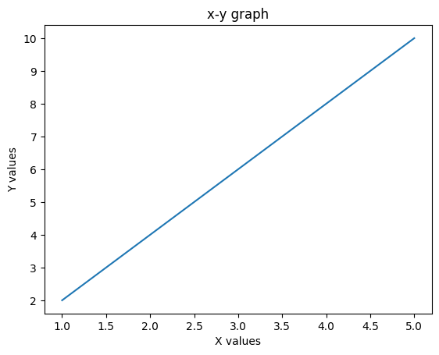

#BAR GRAPH
import matplotlib.pyplot as plt
subjects=['Maths','Physics','Chemistry','CS']
marks=[90,80,70,60]
plt.bar(subjects,marks)
plt.xlabel("Subjects")
plt.ylabel("Marks")
plt.title("Marks in subjects")
plt.show()

output-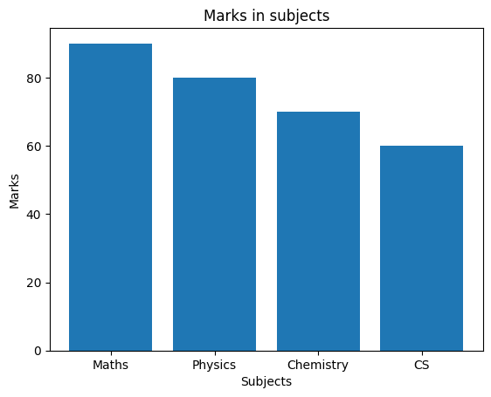

#SCATTERED GRAPH
import matplotlib.pyplot as plt
x=[1,2,3,4,5]
y=[5,7,8,6,9]
plt.scatter(x,y)
plt.xlabel("X values")
plt.ylabel("Y values")
plt.title("Scatter graph")
plt.show()

output-

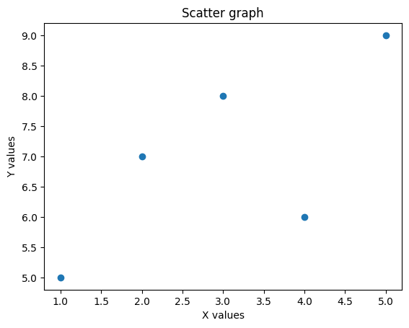

#HISTOGRAM
import matplotlib.pyplot as plt
marks=[90,80,70,60,50,40,30,20,10]
plt.hist(marks)
plt.xlabel("Marks")
plt.ylabel("Frequency")
plt.title("Histogram")

output-
Text(0.5, 1.0, 'Histogram')

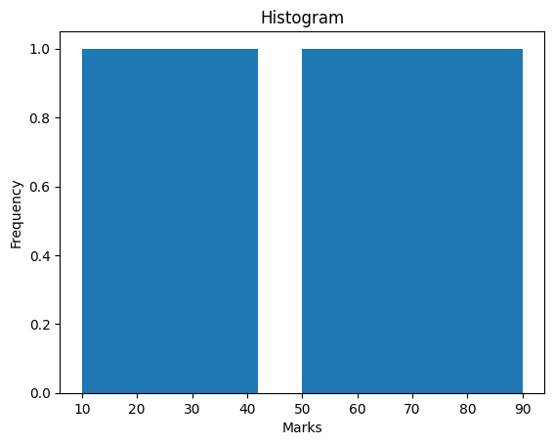

#PIE CHART
import matplotlib.pyplot as plt
activities=['study','sleep','play','others']
hours=[6,4,8,6]
plt.pie(hours,labels=activities,autopct="%1.1f%%")
plt.title("Daily activities")
plt.show()

output-
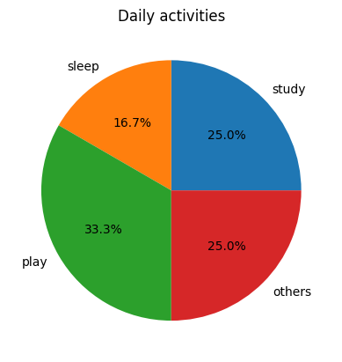

Date:17/02/2025
Week-3
12)Write the code to implement the following operations on any data set reading from url– data filtering, data manipulation, data ranking
import pandas as pd
url = "https://raw.githubusercontent.com/mwaskom/seaborn-data/master/tips.csv"
df = pd.read_csv(url)
print("Original dataset:")
print(df.head())
print("Records where total bill>20 and tip>3:")
filtered_and=df[(df['total_bill']>20) & (df['tip']>3)]
print(filtered_and)
print("Records where day is saturday or sunday")
filtered_or=df[(df['day']=='Sat') | (df['day']=='Sun')]
print(filtered_or)
print("Records where smoker is NOT yes:")
filtered_not=df[~(df['smoker']=='Yes')]
print(filtered_not)
print("\nFemale and non smoker and total bill>15")
combined = df[(df['sex'] == 'Female') & (df['smoker'] == 'No') & (df['total_bill'] > 15)]
print(combined)
print("\nNumber of records satisfying combined condition:",len(combined))
print("Sorted by total bill(Ascending):")
sorted_df=df.sort_values(by='total_bill')
print(sorted_df.head())
print("Sorted by Tip(Descending):")
sorted=df.sort_values(by='tip',ascending=False)
print(sorted.head())
print("\nSorted by day and total bill")
sorted_multi=df.sort_values(by=['day','total_bill'])
print(sorted_multi.head())
print("\nAverage total bill by day")
avg_bill=df.groupby('day')['total_bill'].mean()
print(avg_bill)
print("\nAverage tip by sex and smoker")
avg_tip=df.groupby(['sex','smoker'])['tip'].mean()
print(avg_tip)
print("\ncount of records by day")
count_day=df['day'].value_counts()
print(count_day)

output-
Original dataset:
total_bill tip sex smoker day time size
0 16.99 1.01 Female No Sun Dinner 2
1 10.34 1.66 Male No Sun Dinner 3
2 21.01 3.50 Male No Sun Dinner 3
3 23.68 3.31 Male No Sun Dinner 2
4 24.59 3.61 Female No Sun Dinner 4
Records where total bill>20 and tip>3:
total_bill tip sex smoker day time size
2 21.01 3.50 Male No Sun Dinner 3
3 23.68 3.31 Male No Sun Dinner 2
4 24.59 3.61 Female No Sun Dinner 4
5 25.29 4.71 Male No Sun Dinner 4
7 26.88 3.12 Male No Sun Dinner 4
.. ... ... ... ... ... ... ...
212 48.33 9.00 Male No Sat Dinner 4
214 28.17 6.50 Female Yes Sat Dinner 3
219 30.14 3.09 Female Yes Sat Dinner 4
238 35.83 4.67 Female No Sat Dinner 3
239 29.03 5.92 Male No Sat Dinner 3
[67 rows x 7 columns]
Records where day is saturday or sunday
total_bill tip sex smoker day time size
0 16.99 1.01 Female No Sun Dinner 2
1 10.34 1.66 Male No Sun Dinner 3
2 21.01 3.50 Male No Sun Dinner 3
3 23.68 3.31 Male No Sun Dinner 2
4 24.59 3.61 Female No Sun Dinner 4
.. ... ... ... ... ... ... ...
238 35.83 4.67 Female No Sat Dinner 3
239 29.03 5.92 Male No Sat Dinner 3
240 27.18 2.00 Female Yes Sat Dinner 2
241 22.67 2.00 Male Yes Sat Dinner 2
242 17.82 1.75 Male No Sat Dinner 2

[163 rows x 7 columns]
Records where smoker is NOT yes:
total_bill tip sex smoker day time size
0 16.99 1.01 Female No Sun Dinner 2
1 10.34 1.66 Male No Sun Dinner 3
2 21.01 3.50 Male No Sun Dinner 3
3 23.68 3.31 Male No Sun Dinner 2
4 24.59 3.61 Female No Sun Dinner 4
.. ... ... ... ... ... ... ...
235 10.07 1.25 Male No Sat Dinner 2
238 35.83 4.67 Female No Sat Dinner 3
239 29.03 5.92 Male No Sat Dinner 3
242 17.82 1.75 Male No Sat Dinner 2
243 18.78 3.00 Female No Thur Dinner 2

[151 rows x 7 columns]

Female and non smoker and total bill>15
total_bill tip sex smoker day time size
0 16.99 1.01 Female No Sun Dinner 2
4 24.59 3.61 Female No Sun Dinner 4
11 35.26 5.00 Female No Sun Dinner 4
18 16.97 3.50 Female No Sun Dinner 3
21 20.29 2.75 Female No Sat Dinner 2
22 15.77 2.23 Female No Sat Dinner 2
29 19.65 3.00 Female No Sat Dinner 2
32 15.06 3.00 Female No Sat Dinner 2
33 20.69 2.45 Female No Sat Dinner 4
37 16.93 3.07 Female No Sat Dinner 3
52 34.81 5.20 Female No Sun Dinner 4
57 26.41 1.50 Female No Sat Dinner 2
66 16.45 2.47 Female No Sat Dinner 2
71 17.07 3.00 Female No Sat Dinner 3
85 34.83 5.17 Female No Thur Lunch 4
94 22.75 3.25 Female No Fri Dinner 2
104 20.92 4.08 Female No Sat Dinner 2
114 25.71 4.00 Female No Sun Dinner 3
115 17.31 3.50 Female No Sun Dinner 2
119 24.08 2.92 Female No Thur Lunch 4
125 29.80 4.20 Female No Thur Lunch 6
131 20.27 2.83 Female No Thur Lunch 2
134 18.26 3.25 Female No Thur Lunch 2
140 17.47 3.50 Female No Thur Lunch 2
143 27.05 5.00 Female No Thur Lunch 6
144 16.43 2.30 Female No Thur Lunch 2
146 18.64 1.36 Female No Thur Lunch 3
155 29.85 5.14 Female No Sun Dinner 5
157 25.00 3.75 Female No Sun Dinner 4
162 16.21 2.00 Female No Sun Dinner 3
223 15.98 3.00 Female No Fri Lunch 3
238 35.83 4.67 Female No Sat Dinner 3
243 18.78 3.00 Female No Thur Dinner 2

Number of records satisfying combined condition: 33
Sorted by total bill(Ascending):
total_bill tip sex smoker day time size
67 3.07 1.00 Female Yes Sat Dinner 1
92 5.75 1.00 Female Yes Fri Dinner 2
111 7.25 1.00 Female No Sat Dinner 1
172 7.25 5.15 Male Yes Sun Dinner 2
149 7.51 2.00 Male No Thur Lunch 2
Sorted by Tip(Descending):
total_bill tip sex smoker day time size
170 50.81 10.00 Male Yes Sat Dinner 3
212 48.33 9.00 Male No Sat Dinner 4
23 39.42 7.58 Male No Sat Dinner 4
59 48.27 6.73 Male No Sat Dinner 4
141 34.30 6.70 Male No Thur Lunch 6
Sorted by day and total bill
total_bill tip sex smoker day time size
92 5.75 1.00 Female Yes Fri Dinner 2
222 8.58 1.92 Male Yes Fri Lunch 1
226 10.09 2.00 Female Yes Fri Lunch 2
100 11.35 2.50 Female Yes Fri Dinner 2
97 12.03 1.50 Male Yes Fri Dinner 2

Average total bill by day
day
Fri 17.151579
Sat 20.441379
Sun 21.410000
Thur 17.682742
Name: total_bill, dtype: float64

Average tip by sex and smoker
sex smoker
Female No 2.773519
Yes 2.931515
Male No 3.113402
Yes 3.051167
Name: tip, dtype: float64
count of records by day
day
Sat 87
Sun 76
Thur 62
Fri 19
Name: count, dtype: int64

13)Write the code to implement the following descriptive statistics operations any of the created data frame– mean, median, mode, standard deviation, variance, kurtosis, skewness
import matplotlib.pyplot as plt
import numpy as np
import pandas as pd
data=[10,12,15,18,20,22,25,30,35,40]
df=pd.DataFrame(data,columns=['values'])
print("Dataset:")
print(df)
print("\nSummary statistics:")
print(df.describe())
print("\nVariance:",np.var(data))
print("\nStandard deviation:",np.std(data))
plt.hist(data)
plt.xlabel('Values')
plt.ylabel('Frequency')
plt.title('Data Distribution')
plt.show()
mean_value=np.mean(data)
median_value=np.median(data)
mode_value = df['values'].mode()
print("\nInference:")
print("Mean:",mean_value)
print("Median:",median_value)
if len(mode_value) == 1:
print("Mode:", mode_value[0])
else:
print("Mode:", list(mode_value))
if mean_value>median_value:
print("The distribution is positively skewed.")
elif mean_value<median_value:
print("The distribution is negatively skewed.")
else:
print("The distribution is symmetric.")

output-
Dataset:
values
0 10
1 12
2 15
3 18
4 20
5 22
6 25
7 30
8 35
9 40

Summary statistics:
values
count 10.000000
mean 22.700000
std 9.855061
min 10.000000
25% 15.750000
50% 21.000000
75% 28.750000
max 40.000000

Variance: 87.41

Standard deviation: 9.34933152690608

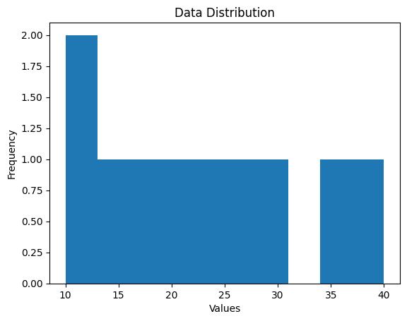
Inference:
Mean: 22.7
Median: 21.0
Mode: [10, 12, 15, 18, 20, 22, 25, 30, 35, 40]
The distribution is positively skewed.

Questions 14 and 15) Read any of the data set from URL and perform descriptive statistic functions and perform the data visualization methods
import matplotlib.pyplot as plt
import numpy as np
import pandas as pd
url = "https://raw.githubusercontent.com/mwaskom/seaborn-data/master/iris.csv"
print("Dataset:")
df = pd.read_csv(url)
print(df.head())
data = df['sepal_length']
print("\nSummary statistics:")
print(data.describe())
print("\nVariance:", np.var(data))
print("Standard deviation:", np.std(data))
# Mean, Median, Mode
mean_value = np.mean(data)
median_value = np.median(data)
mode_value = data.mode()
# Histogram
plt.hist(data, bins=10, color='skyblue', edgecolor='black')
plt.axvline(mean_value, color='red', linestyle='dashed',
linewidth=2, label=f"Mean: {mean_value:.2f}")
plt.axvline(median_value, color='green', linestyle='dashed',
linewidth=2, label=f"Median: {median_value:.2f}")
plt.xlabel('Sepal Length')
plt.ylabel('Frequency')
plt.title('Distribution of Sepal Length')
plt.legend()
plt.show()
print("\nInference:")
print("Mean:", mean_value)
print("Median:", median_value)
if len(mode_value) == 1:
print("Mode:", mode_value[0])
else:
print("Mode:", list(mode_value))
if mean_value > median_value:
print("The distribution is positively skewed.")
elif mean_value < median_value:
print("The distribution is negatively skewed.")
else:
print("The distribution is symmetric.")

output-
Dataset:
sepal_length sepal_width petal_length petal_width species
0 5.1 3.5 1.4 0.2 setosa
1 4.9 3.0 1.4 0.2 setosa
2 4.7 3.2 1.3 0.2 setosa
3 4.6 3.1 1.5 0.2 setosa
4 5.0 3.6 1.4 0.2 setosa

Summary statistics:
count 150.000000
mean 5.843333
std 0.828066
min 4.300000
25% 5.100000
50% 5.800000
75% 6.400000
max 7.900000
Name: sepal_length, dtype: float64

Variance: 0.6811222222222222
Standard deviation: 0.8253012917851409

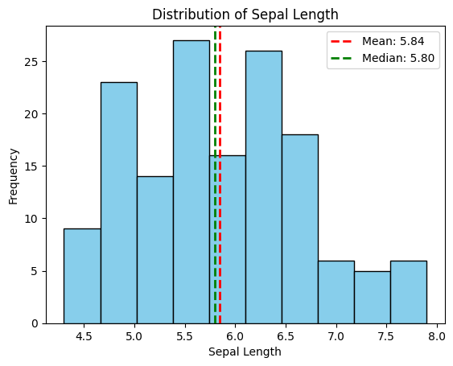
Inference:
Mean: 5.843333333333334
Median: 5.8
Mode: 5.0
The distribution is positively skewed.

15)Read any of the datasets from url and perform data visualization operations
# Import required libraries
import pandas as pd
import matplotlib.pyplot as plt
# Step 1: Read dataset from URL
url = "https://raw.githubusercontent.com/mwaskom/seaborn-data/master/iris.csv"
df = pd.read_csv(url)
# Step 2: Display first 5 rows
print("First 5 rows of dataset:")
print(df.head())
# Step 3: Dataset information
print("\nDataset Info:")
print(df.info())
# -----------------------------
# Data Visualization
# -----------------------------
#Line Plot - Sepal Length
plt.figure()
plt.plot(df['sepal_length'])
plt.title("Sepal Length Line Plot")
plt.xlabel("Index")
plt.ylabel("Sepal Length")
plt.show()
#Histogram - Petal Length
plt.figure()
plt.hist(df['petal_length'], bins=20)
plt.title("Petal Length Distribution")
plt.xlabel("Petal Length")
plt.ylabel("Frequency")
plt.show()
#Scatter Plot - Sepal vs Petal Length
plt.figure()
plt.scatter(df['sepal_length'], df['petal_length'])
plt.title("Sepal Length vs Petal Length")
plt.xlabel("Sepal Length")
plt.ylabel("Petal Length")
plt.show()
#Bar Plot - Species Count
plt.figure()
df['species'].value_counts().plot(kind='bar')
plt.title("Species Count")
plt.xlabel("Species")
plt.ylabel("Count")
plt.show()
#Pie Chart - Species Distribution
plt.figure()
species_count = df['species'].value_counts()

plt.pie(species_count,
labels=species_count.index,
autopct='%1.1f%%',
startangle=90)

plt.title("Species Distribution Pie Chart")
plt.axis('equal') # Makes it a perfect circle
plt.show()

output-
First 5 rows of dataset:
sepal_length sepal_width petal_length petal_width species
0 5.1 3.5 1.4 0.2 setosa
1 4.9 3.0 1.4 0.2 setosa
2 4.7 3.2 1.3 0.2 setosa
3 4.6 3.1 1.5 0.2 setosa
4 5.0 3.6 1.4 0.2 setosa

Dataset Info:
<class 'pandas.core.frame.DataFrame'>
RangeIndex: 150 entries, 0 to 149
Data columns (total 5 columns):
# Column Non-Null Count Dtype
--- ------ -------------- -----
0 sepal_length 150 non-null float64
1 sepal_width 150 non-null float64
2 petal_length 150 non-null float64
3 petal_width 150 non-null float64
4 species 150 non-null object
dtypes: float64(4), object(1)
memory usage: 6.0+ KB
None

